**How to feed your horse during the winter?**

Winter conditions differ between the geographic regions, for that reason exact recommendations regarding nutritional needs that would be applicable to all horses can be a challenge.

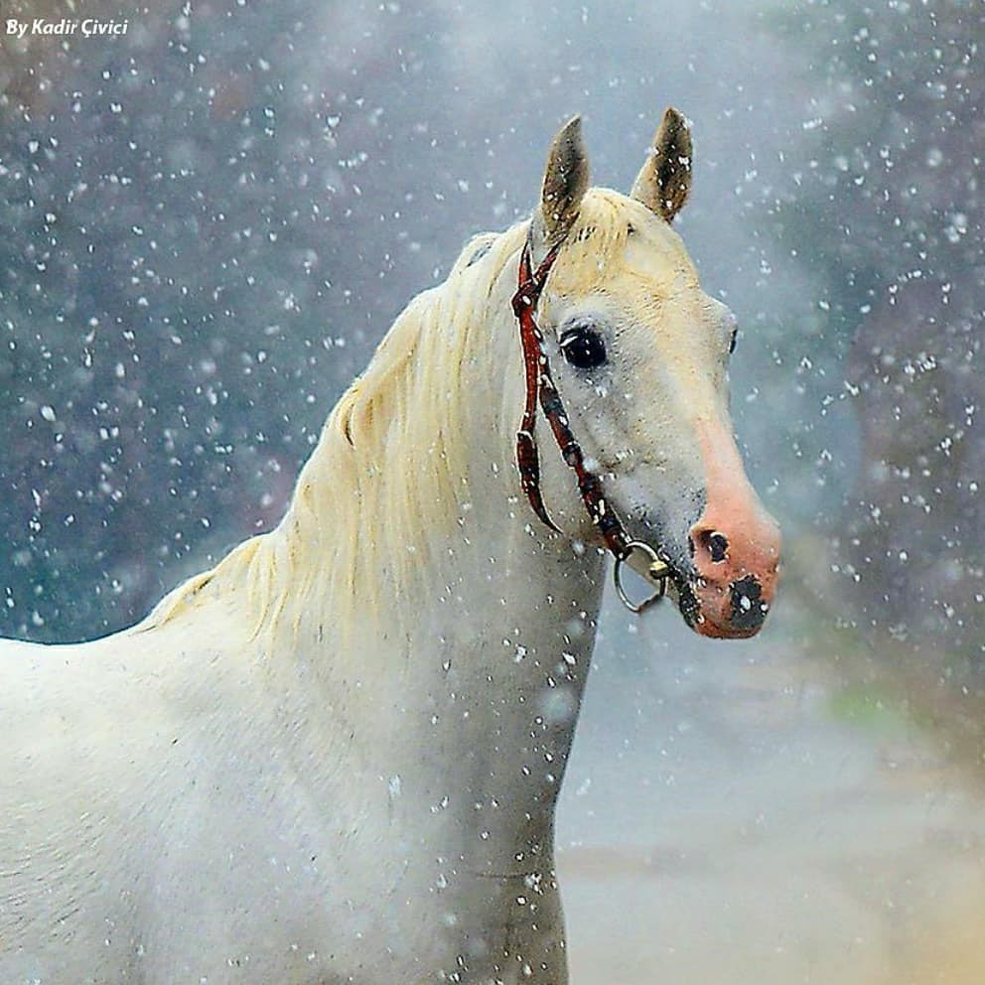

In the winter months many horses will need extra energy to maintain their body temperature and keep their body warm. The exact amount of increase on the energy requirement depends on the severity and extent of the cold period. When environmental temperatures drop to lower critical temperature (LCT is the minimum body temperature that can be tolerated by a horse), horses nutritional requirements change to maintain normal body temperature. LCT of an individual horse will depend on the temperatures to which it is accustomed, and warmness of the stables. In general, for every 1 degree below critical temperature, the horse requires an increase 1% in digestible energy. It is also important to consider that aged horses (>20 years) have reduced tolerance of cold weather and will need higher energy intakes than young horses housed under the same conditions.

Every situation is different and the horses are individuals. The major nutritional concerns for horses during the winter months have sufficient energy to maintain good body condition, to do their work and easily access to fresh, clean and unfrozen water sources.

* Forage should remain horses primary ration, since forage is much more efficient and effective to create internal heat (due to the fermentation process the forage goes through in the hindgut) than starch from concentrate feed to maintain body heat. Horses should be fed with at least 1.5 to 2% dry matter forage for body weight of horses in winter months. Bear in mind however that this is the minimum dry matter amount you should be feeding not as fed basis. As an example, if hay is about 15% water and 85% dry matter, 10 kg hay equals 10 x 0,85 = 8.5 kg dry matter.
* Use of the higher protein legume such as alfalfa should be minimized to prevent from adverse air quality issues due to the increased ammonia excretion in stabled horses.
* Additional concentrate feed will require for horses in full work throughout the winter. Provide calories through oil or rice bran rather than through cereals such as oat and barley. Consumption of grain does not produce large amounts of body heat during digestion.
* Vitamin-mineral supplements may be added to the diet, but not because the daily requirement of the horse increases, especially because some antioxidants vitamins A, E and C reduced in the forage due to prolonged storage since summer. There are no specific winter supplements.

For further details contact with equine nutritionist who will advise you.

